Report assignment 3
Shahar navian 325895332
Nehoray chalphon
Question 1:

Question 2:
a) First, I loaded the CSV files and merged product_descriptions into the training set by product_uid, so every training row has a search_term, product_title, and product_description (no missing descriptions in the train sample). Before tokenizing, I applied Unicode normalization (NFKC), lowercasing, and converted missing values to an empty string, so the preprocessing is consistent and does not break on noisy text.
Next, I built a custom tokenizer to create word / character-combination tokens (these are the “words” used later). The tokenizer uses a single regex that keeps important patterns as single tokens instead of splitting them: hashtags/codes (like #SC), numbers and measurements including optional degree sign (like 3.5, 90°), Unicode fraction symbols (like ¾), and hyphenated/alphanumeric forms (like wire-backed, pull-out, in-store, x9ft). Any leftover punctuation or symbols are kept as separate small tokens only when needed, so the model can still see structure like 1/8 or parentheses.
Finally, I ran this tokenizer on the relevant text fields (query, title, description) and stored the resulting ordered token lists per example. I also verified on real samples that the tokenizer behaves as intended (like 4x9ft wall paneling → ['4','x9ft','wall','paneling'] and wire-backed stays one token). These token sequences are the direct input for the word/byte-pair embedding step and for the word/character-combination level model in the next parts.
b) First, I trained Word2Vec embeddings on the training split only (tr) to avoid leakage from validation or test. The training corpus was built from tokenized queries and tokenized documents (document = product_title + [SEP] + product_description). I used 200-dimensional vectors with a skip-gram setup (sg=1, window=5, negative=10, min_count=2, epochs=5) so the embeddings learn useful patterns directly from the e-commerce text.
Next, I built a clean vocabulary for the neural model by adding two special tokens: <PAD> for padding and <UNK> for unseen tokens. <PAD> gets a zero vector and <UNK> gets a small random vector, while all other tokens use their learned Word2Vec vectors. This creates one embedding matrix that is loaded into a PyTorch nn.Embedding layer. The embedding layer is initialized with these vectors and then trained end-to-end with the downstream model, so the embeddings can be fine-tuned for the relevance task.
Finally, I applied truncation to control runtime and memory: queries are limited to 16 tokens (Q_MAX_TOK=16) and documents are limited to 256 tokens (D_MAX_TOK=256) for the model input. Separately, when building the Word2Vec corpus I allowed up to 1024 document tokens (DOC_EXTRA_CAP=1024), so Word2Vec can learn from richer description context even though the downstream model uses a shorter fixed input.
c) To predict relevance, I used a Siamese network with a shared sequence encoder. The same BiLSTM encoder is applied to the query tokens and to the document tokens (document = title + description), which puts both sides in the same representation space and makes their comparison more consistent. To get a fixed size representation, I used masked mean pooling over the BiLSTM outputs: padding positions (<PAD>) are ignored using a mask (x != pad_idx), so the average is computed only over real tokens.
I then combined the two vectors using standard similarity features: concatenation of q, d, |q-d|, and q*d. These features go into a small MLP head that outputs a single real number (relevance), so the task is treated as regression.
Training used MSE loss with AdamW (learning rate 2e-3), batch size 256, 6 epochs, and gradient clipping (max norm 1.0) for stability. I logged metrics with W&B and saved the best checkpoint based on validation RMSE. The best model achieved: Train RMSE 0.4015 / MAE 0.3294, Val RMSE 0.5067 / MAE 0.4165, and Test RMSE 0.5525 / MAE 0.4561. For test evaluation, I matched predictions to testLabels.csv by id and evaluated only on rows with Usage ∈ {Public, Private}, ignoring Usage = Ignored (n = 112,067). The train RMSE is better than the val RMSE but this is probably due to overfit so that’s why I save the best model by val.
d) I used pretrained Sentence-Transformers as a feature extractor to embed the query and the document into fixed-size vectors. The document text was built as product_title + [SEP] + product_description. The SentenceTransformer encoder was used as a frozen feature extractor (no fine-tuning), and only the downstream regressor was trained. I encoded all queries and documents for train/val using model.encode with normalize_embeddings=True, so cosine similarity can be computed directly as the dot product.
From the query and document embeddings, I built a single feature vector per pair using common matching features: [q_emb, d_emb, |q_emb − d_emb|, q_emb * d_emb, cosine(q,d)]. These features were fed into a small MLP regressor (two hidden layers with dropout) that predicts the relevance score.
I trained the MLP with MSE loss and AdamW (lr=2e-3) for 10 epochs. I used a shuffled loader for training, but no shuffling for evaluation loaders to keep predictions aligned with the label arrays. I saved the best checkpoint by validation RMSE, and evaluated on the labeled part of the test set by merging predictions with testLabels.csv by id and ignoring rows with Usage = Ignored.
Results:
- all-MiniLM-L6-v2: Train RMSE 0.4328 / MAE 0.3497, Val RMSE 0.4594 / MAE 0.3703, Test RMSE 0.4792 / MAE 0.3884 (runtime ~190s).
- all-mpnet-base-v2: Train RMSE 0.4170 / MAE 0.3382, Val RMSE 0.4524 / MAE 0.3653, Test RMSE 0.4766 / MAE 0.3866 (runtime ~1345s).

question 3:
Model type | Runtime (sec) | Train RMSE | Val RMSE | Test RMSE | Train MAE | Val MAE | Test MAE
Character-level Siamese (CharCNN+BiLSTM) | 1689 | 0.4855 | 0.4987 | 0.5297 | 0.4031 | 0.4130 | 0.4391
Word level Siamese BiLSTM + Word2Vec | 160 | 0.4015 | 0.5067 | 0.5525 | 0.3294 | 0.4165 | 0.4561
Word feature extractor: MLP | all-MiniLM-L6-v2 | 190 | 0.4328 | 0.4594 | 0.4792 | 0.3497 | 0.3703 | 0.3884
Word feature extractor: MLP | all-mpnet-base-v2 | 1345 | 0.4170 | 0.4524 | 0.4766 | 0.3382 | 0.3653 | 0.3866
Word feature extractor: microsoft/deberta-v3-base | 1650 | 0.5050 | 0.5030 | 0.5142 | 0.4148 | 0.4118 | 0.4223
Char feature extractor: google/byt5-small | 3143 | 0.5078 | 0.5101 | 0.5302 | 0.4156 | 0.4165 | 0.4331
Char feature extractor: google/byt5-base | 6002 | 0.4847 | 0.4945 | 0.5234 | 0.3906 | 0.3979 | 0.4212
Char feature extractor: google/canine-s | 713 | 0.4899 | 0.4988 | 0.5152 | 0.4015 | 0.4083 | 0.4230

Question 4:
Preface
The goal of this research is to predict a search relevance score between a user query (search_term) and a product (product_title + product_description). This is a regression task: the model outputs one real value, and performance is measured mainly with RMSE and MAE. The main difficulty is that e-commerce text is noisy and inconsistent. Queries are short, product text is long, and important details often appear as special patterns such as measurements, fractions, and codes (for example “90°”, “¾”, “x9ft”, “#SC”). Another key challenge is building methods that generalize well and do not rely on accidental dataset artifacts.
To solve the task, I tried several approaches at different text-processing levels. First, I designed a custom tokenizer that produces word / character-combination tokens that preserve meaningful patterns. Then I trained Word2Vec embeddings on the training split and used them inside a Siamese BiLSTM regressor. After that, I moved to stronger pretrained encoders used as frozen feature extractors, both at word/subword level (Sentence-Transformers and DeBERTa) and at byte/character level (ByT5 and CANINE). In all feature-extractor approaches, the encoder itself was not fine-tuned; only a small MLP regressor was trained on top of similarity features derived from the embeddings.
The main conclusion is that word-level pretrained encoders used as feature extractors (especially MPNet and MiniLM) produced the best overall performance on the test set. They clearly outperformed the Word2Vec+BiLSTM model and also outperformed the byte/character feature extractors. MiniLM was almost as accurate as MPNet but much faster, which makes it a strong practical choice.
Data preparation and preprocessing
I loaded the CSV files and merged product_descriptions into the data using product_uid, so each example contains search_term, product_title, and product_description. Before tokenization, I applied Unicode normalization (NFKC), lowercasing, and converted missing values to an empty string. This makes preprocessing stable and consistent even when the text contains unusual symbols or missing fields.
For the test evaluation, I generated predictions for the test set and then joined them with testLabels.csv using the id column. I evaluated only the rows that are actually scored (Usage is Public or Private) and skipped the rows marked as Ignored. This left 112,067 labeled test examples. I used the same evaluation procedure for all models.
tokenization methods used:
Word / “word-like” tokenizer (used for Word2Vec and the word-level Siamese model)
I built a custom tokenizer using a single regex, designed to keep meaningful e-commerce patterns as single tokens rather than splitting them incorrectly. It preserves hashtags/codes (like “#SC”), numbers and measurements including degree sign (like “3.5”, “90°”), Unicode fractions (like “¾”), and hyphenated/alphanumeric forms (like “wire-backed”, “pull-out”, “x9ft”). Any leftover punctuation is kept only when useful, so the model can still see structure such as “1/8” or parentheses. For example, “4x9ft wall paneling” becomes tokens like [“4”, “x9ft”, “wall”, “paneling”], and “wire-backed” remains one token.
Pretrained tokenizers (used for feature extractor models)
For the feature extractor models, tokenization is performed internally by the pretrained model’s tokenizer. Sentence-Transformers and DeBERTa use subword tokenization, while ByT5 works over bytes and CANINE is character-focused. In these models, I did not design tokens manually; instead, the pretrained tokenizer maps the raw text into the model’s representation.
Methods tried:
2b — Word2Vec embeddings
I trained a Word2Vec model only on the training split (tr) to avoid leakage from validation or test. The training corpus was built from tokenized queries and tokenized documents (document = product_title + [SEP] + product_description). I used 200-dimensional vectors with skip-gram (sg=1), window size 5, negative sampling 10, min_count 2, and 5 epochs. After training, I created a vocabulary with two special tokens: <PAD> for padding and <UNK> for unseen tokens. <PAD> was assigned a zero vector, <UNK> a small random vector, and all other tokens used their learned Word2Vec vectors. This embedding matrix was loaded into a PyTorch nn.Embedding layer and then fine-tuned during downstream training.
To control runtime and memory, I truncated queries to 16 tokens and documents to 256 tokens for the neural model input. Separately, when building the Word2Vec corpus, I allowed up to 1024 document tokens so Word2Vec can learn from more description context even though the downstream model uses a shorter fixed input.
2c — Word-level Siamese BiLSTM regressor (with Word2Vec)
To predict relevance, I used a Siamese architecture with a shared BiLSTM encoder. The same encoder processes the query token sequence and the document token sequence, and each side produces a fixed-size vector using masked mean pooling (padding positions are ignored). I then combined the two vectors using standard matching features: concatenation of q, d, |q−d|, and q*d. A small MLP head outputs one relevance value, so the task is treated as regression.
Training used MSE loss with AdamW (lr=2e-3), batch size 256, 6 epochs, and gradient clipping (max norm 1.0). I saved the best checkpoint based on validation RMSE. The training RMSE was much lower than validation RMSE, which suggests overfitting, so selecting by validation RMSE was important.
2d — Feature extractor + MLP regressor (word-level and byte/character-level)
In this approach, I treated a pretrained encoder as a frozen feature extractor. I embedded the query and document separately, built a single feature vector per pair, and trained only a small MLP regressor. The document text was built as product_title + [SEP] + product_description. Embeddings were normalized, so cosine similarity can be computed as a dot product.
For each query–document pair, I built matching features: [q_emb, d_emb, |q_emb − d_emb|, q_emb*d_emb, cosine(q,d)]. These were fed into an MLP regressor with dropout to predict relevance. Training used MSE loss and AdamW (lr=2e-3). I trained for 10 epochs for the Sentence-Transformer runs, saved the best checkpoint by validation RMSE, and evaluated on the test labeled subset using the id-merge and Usage filtering.
I ran this setup with multiple encoders:
- Word-level feature extractors: all-MiniLM-L6-v2, all-mpnet-base-v2, microsoft/deberta-v3-base
- Byte/character-level feature extractors: google/byt5-small, google/byt5-base, google/canine-s

From the result table, the best test RMSE was achieved by all-mpnet-base-v2 (0.4766), with all-MiniLM-L6-v2 (0.4792) very close but much faster. The byte/character feature extractors (CANINE, ByT5) improved over the Word2Vec Siamese model but did not beat the best word-level Sentence-Transformers. DeBERTa-v3-base was competitive but weaker here than MPNet/MiniLM in this feature-extractor setup.

Final remarks
The strongest insight is that good pretrained semantic embeddings are extremely effective for query–document relevance, even without fine-tuning the encoder. A frozen Sentence-Transformer encoder plus a simple MLP regressor generalized better than the Word2Vec + BiLSTM model and achieved the best test scores.
There is also a clear runtime trade-off. MPNet gave the best accuracy but took much longer. MiniLM was almost as accurate and far faster, which suggests it is a better practical baseline for deployment.
If I continue exploring, the most promising next step is to fine-tune a strong pretrained encoder directly for relevance instead of freezing it, because the encoder can adapt its representations to the task. Another strong direction is better handling of long descriptions (chunking, attention pooling, or selecting the most relevant sentences) so truncation does not drop important information. Finally, adding explicit matching signals (like exact number/measurement matches) as extra features could help because these patterns are very common in e-commerce relevance.

MORE PLOTS IN THE NEXT PAGES
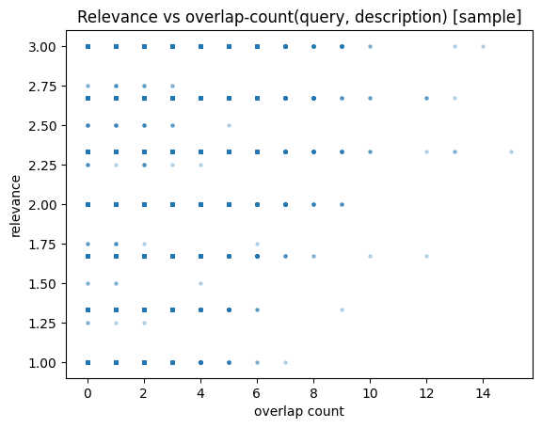
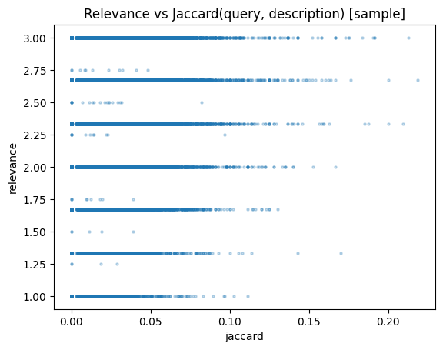
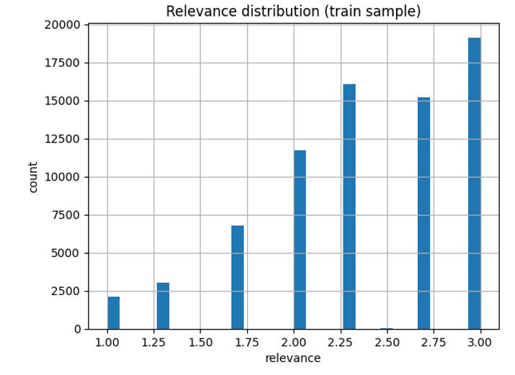
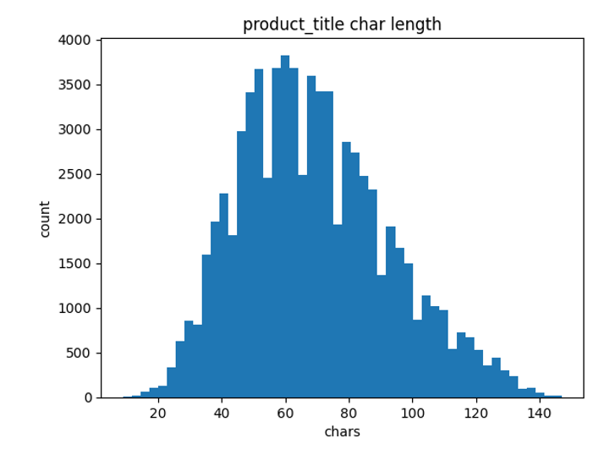
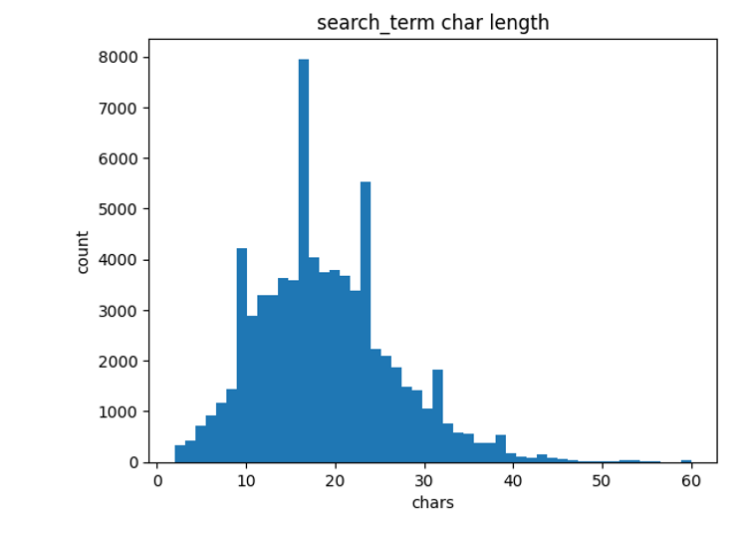
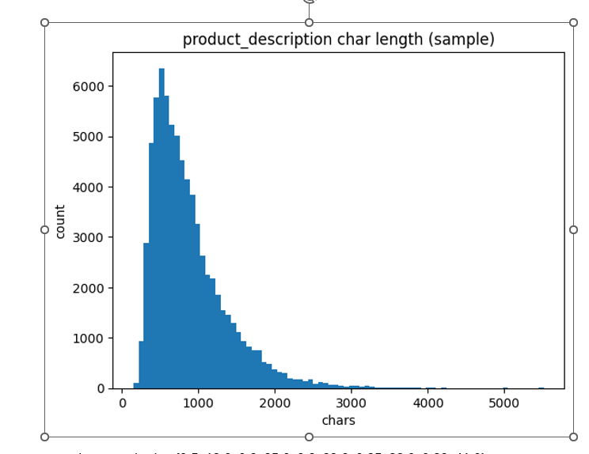

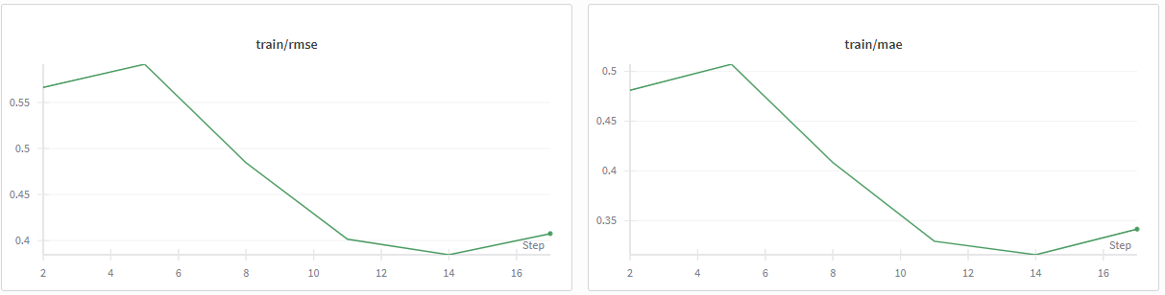
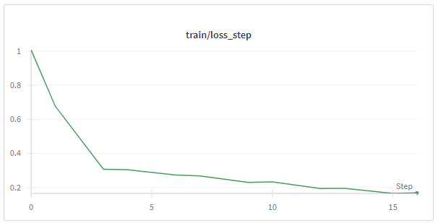
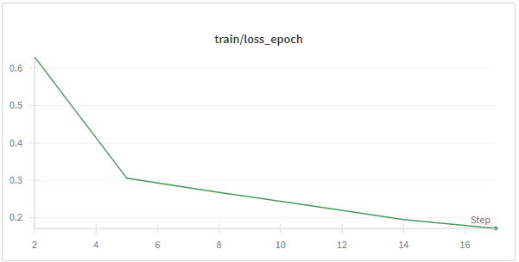
Word level Siamese BiLSTM + Word2Vec
Word feature extractor + MLP (Sentence-Transformers)
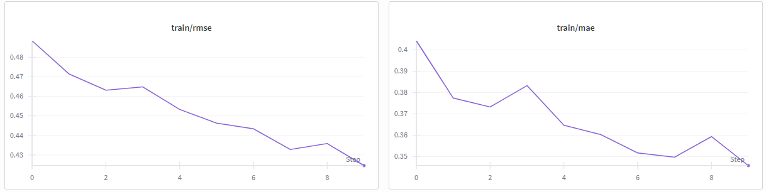
MiniLM-L6-v2:
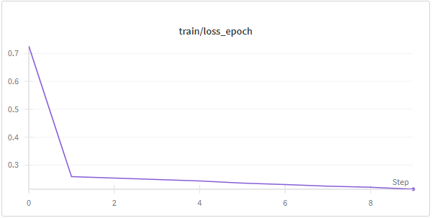

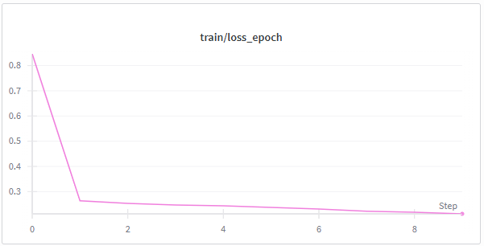
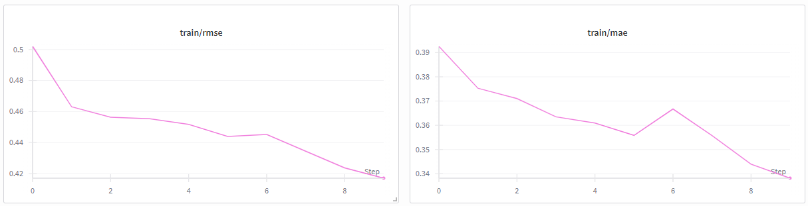
mpnet-base-v2:

Char feature extractor + MLP
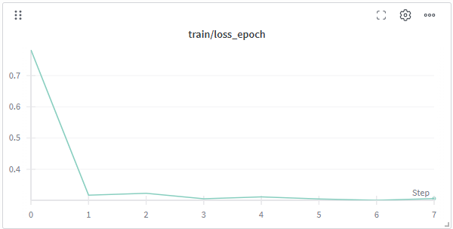
google_byt5-small:
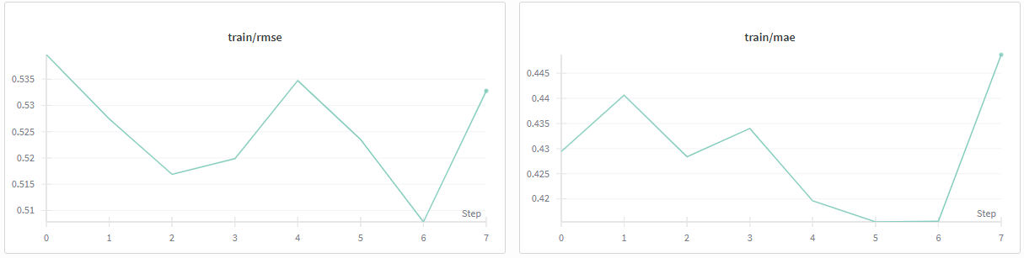
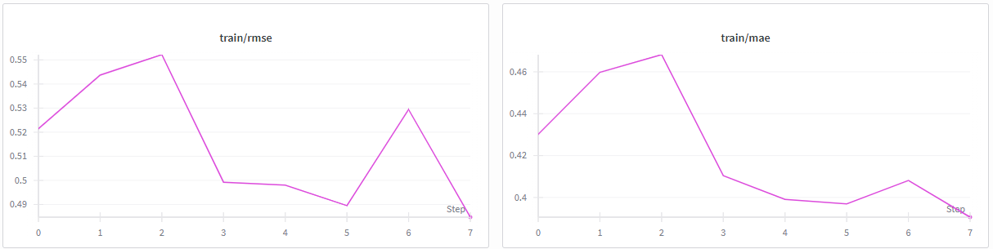
google_byt5-base: 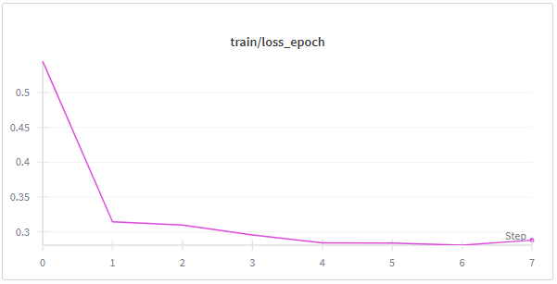

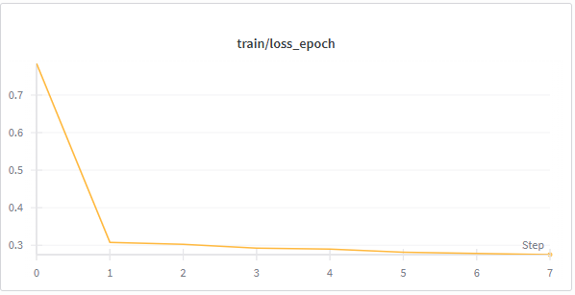
google_canine-s:

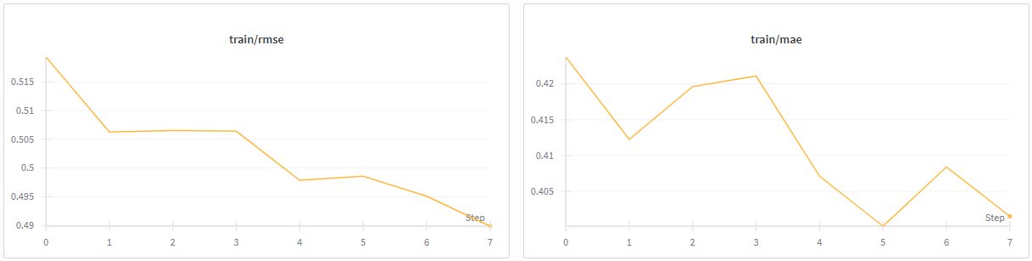

Word feature extractor deberta-v3-base:
